UCI AMC 8 Practice Test: Hard

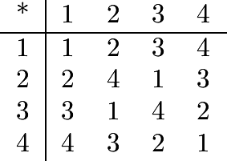
1. Consider the operation defined by the following table:

For example, . Then 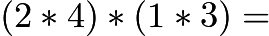

2. There is a set of five positive integers whose average (mean) is 5, whose median is 5, and whose only mode is 8. What is the difference between the largest and smallest integers in the set?

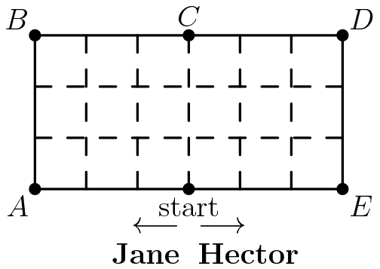
3. Jane can walk any distance in half the time it takes Hector to walk the same distance. They set off in opposite directions around the outside of the 18-block area as shown. When they meet for the first time, they will be closest to

4. The arithmetic mean (average) of four numbers is . If the largest of these numbers is , then the mean of the remaining three numbers is

5. What is the units digit of 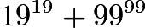?

6. Homer began peeling a pile of 44 potatoes at the rate of 3 potatoes per minute. Four minutes later Christen joined him and peeled at the rate of 5 potatoes per minute. When they finished, how many potatoes had Christen peeled?

7. Each corner cube is removed from this cube. The surface area of the remaining figure is
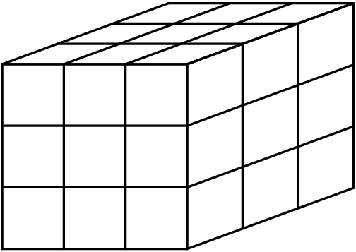

8. Ana's monthly salary was in May. In June she received a raise. In July she received a pay cut. After the two changes in June and July, Ana's monthly salary was

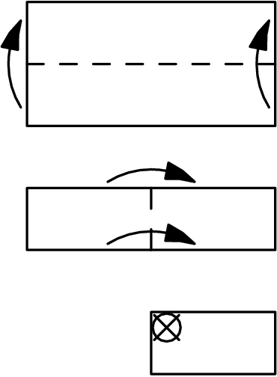
9. As indicated by the diagram below, a rectangular piece of paper is folded bottom to top, then left to right, and finally, a hole is punched at X. What does the paper look like when unfolded?

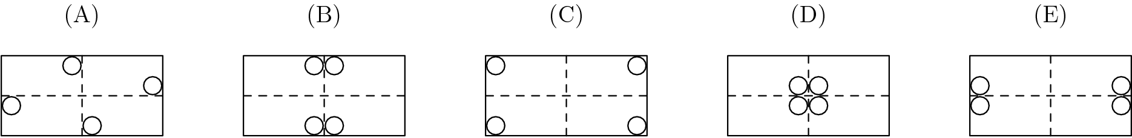
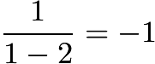
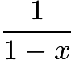
10. Suppose there is a special key on a calculator that replaces the number currently displayed with the number given by the formula . For example, if the calculator is displaying and the special key is pressed, then the calculator will display since
. Now suppose that the calculator is displaying . After the special key is

pressed 100 times in a row, the calculator will display

11. All of the even numbers from 2 to 98 inclusive, excluding those ending in 0, are multiplied together. What is the rightmost digit (the units digit) of the product?

12. Three generous friends, each with some money, redistribute the money as follows:
Amy gives enough money to Jan and Toy to double each amount has.
Jan then gives enough to Amy and Toy to double their amounts.
Finally, Toy gives enough to Amy and Jan to double their amounts.
If Toy had 36 dollars at the beginning and 36 dollars at the end, what is the total amount that all three friends have?

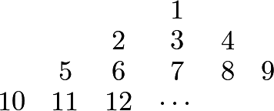
13. What number is directly above in this array of numbers?

14. Points 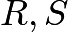 and are vertices of an equilateral triangle, and points and are midpoints of its sides. How many noncongruent triangles can be drawn using any three of these six points as vertices?
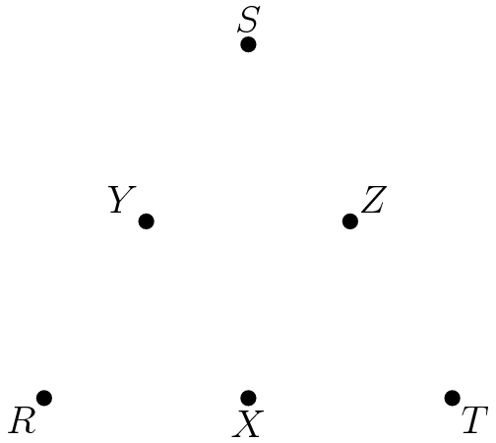

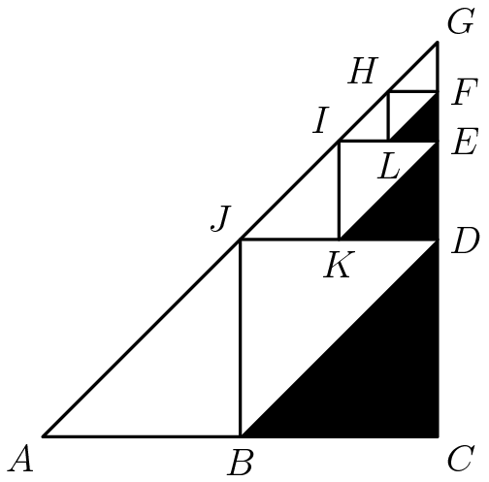
15. Points , , and are midpoints of the sides of right triangle . Points , , are midpoints of the sides of triangle , etc. If the dividing and shading process is done 100 times (the first three are shown) and ,then the total area of the shaded triangles is nearest

